CURRICULUM VITAE
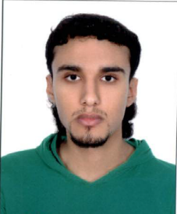
PERSONAL INFORMATION:
Name: Ahmed Abdulla Mohammed Abdulla
C.P.R No.: 930202929
Sex: Male
Nationality: Bahraini
Marital Status: single
Address: House; 730 Road; 2623 Block; 1026 – karzakan _ Bahrain
Telephone No.: 33951030 - 33271542 -17600818
Email: halaam79@hotmail.com

ACADEMIC QUALIFICATIONS:
2010 – 2011 : Complete the first year of industrial track.
2005 – 2008 : Intermediate certificate.

LANGUAGES:
Speaking, reading and writing of both Arabic & English

COMPUTER SKILLS:
- Microsoft Word
- Microsoft Excel
- Internet Explorer

